Philadelphia Baptist Church
5709 Philadelphia Church Road, Marshville, NC 28103; 704-624-5121
Website: pbcmarshville.org E-mail: philadelphia1@windstream.net
____________________________________________________________________________
Dear Family of God of Philadelphia,
“Be cheerful no matter what; pray all the time;
thank God no matter what happens.
This is the way God wants you who belong to Christ Jesus to live.”
I Thessalonians 5:16 – 18 The Message
Most days, I spend at least a part of my day trying to minister to someone in crisis. Sometimes, I sit with a family while their loved one is in surgery. Many times, I walk with families through their grief. It is not uncommon for me to speak with a parent or a grandparent who has a problem or prodigal child. And far too often these days, I counsel with those who are having problems in their marriage. As soon as I finish this article, I will be headed to a meeting in one of our local schools to serve as a “surrogate parent” for a child who has seen more tragedy than any child should have to bear. This is the calling that God has placed on my life, and I am grateful and honored that God would entrust this ministry to me.
There are days, however when “being cheerful” or “thanking God no matter what happens” seems like an impossible task. How can we remain cheerful when our bodies are in pain? How can we be thankful for bills we can’t pay? How can we celebrate the Thanksgiving holiday when there are empty seats at the table?
The key, I believe, is tucked away in this verse right between those two difficult commands. We are to “pray all the time.” When we pray, we become aware that “God is a safe place to hide, ready to help when we need Him.”(Psalm 46:1 The Message) When we pray, we are reminded that “Even though on the outside it often looks like things are falling apart on us, on the inside, where God is making new life, not a day goes by without His unfolding grace.” (II Corinthians 4:16-17 The Message) When we pray we come to understand that “you’re My servant, serving on My side. I’ve picked you. I haven’t dropped you. Don’t panic. I’m with you. There’s no need to fear for I’m your God. I’ll give you strength. I’ll help you. I’ll hold you steady; keep a firm grip on you.” (Isaiah 41: 9-10 The Message) In the middle of your storm, give thanks. This is how God wants us who belong to Him to live.
May our Father bless you today. It is a joy to serve our Lord with you. RCA
FAMILY LIFE CENTER RESERVATIONS
In an effort top better serve us all, when you or your group wants to use the Family Life Center for an event, please fill out a FLC request form (forms located in vestibule and outside secretary’s office) and turn it in to the secretary’s mailbox located beside office door or secretary’s mailbox located in the Sunday School Office. Approved events will be scheduled on a first come, first serve basis. All events must be approved by the deacons. We are blessed to have such a wonderful facility that many groups want to use, so we want to be fair with all. Thank you for your understanding in this.
__________________________________________________________________
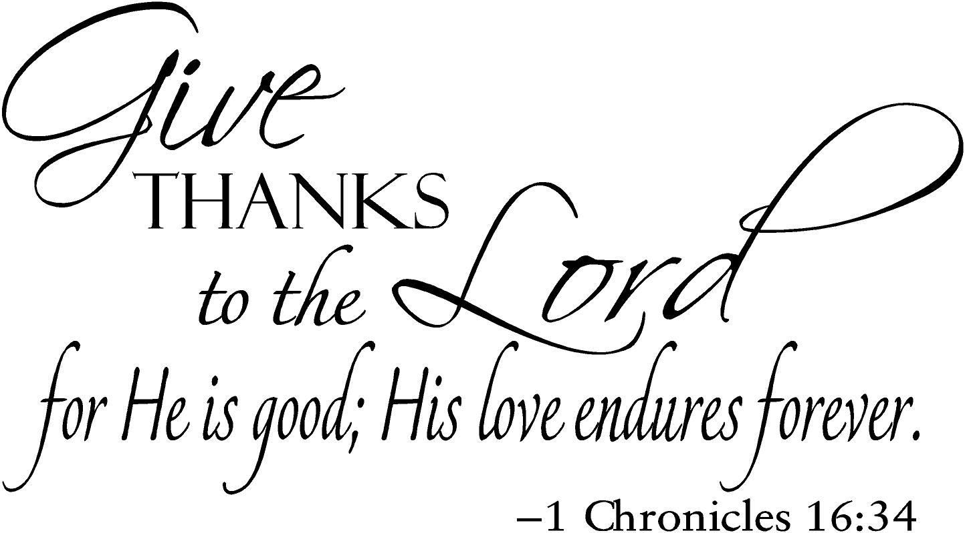
2- Jeff Forester, Jack Rollins, Hailey Turner
3-Brenda Wallace, Raleigh Hinson
4-Cecil Helms, Donald Sullivan
5-Grayson Helms, Mitchell Wilson
9-Joyce Ashcraft, J.D. Query
10-Vanna Nash
13-Bonnie Newland
14-Noah Porter
15-Oakley Hinson
18-Beth Atkinson, Tommy Pittman
20-Riley Benton
23-Dawn McClain
25-Ava Strawn
27-Tonya Huggins
29-Frances Baker
30-Jerry Davis

NURSERY WORKERS
November 4th - Kaylee Duke and Lacy Lee
November 11th - Lauren Davis and Mindy Jenkins
November 18th - Deborah Sullivan and Peggy Smith
November 25th - Sheree Jenkins and Kara Keith
___________________________________________________________

NOVEMBER CHILDREN’S CHURCH WORKERS
Children’s Church is for ages 2 to 5 years old.
2 & 3 Year Old’s 4 & 5 Year Old’s
4th: Deborah Sullivan & Jennifer Helms Deneice Hendrick & Erin Felt
11th: Crystal Craig & Chad Clay Tony & Kara Keith
18​^{th}: Tonya & Kerstyn Helms Skyla Anderson & Luisa Price
25th: Lauren Duke & Helper Lauren Davis & Mindy Jenkins
_________________________________________
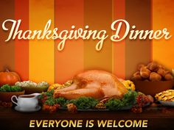
DATE: Saturday, November 17th
TIME: 6:00 PM
PLACE: Family Life Center

AMONA CLASS MISSION PROJECT

The Amona Sunday School Class is collecting pop-top canned meats, gallon jugs of water and 9 x 12 tarps till the end of November for the Tent City Ministry, which is a part of Operation Reach Out Ministries, founded in November 2016 for people of "no fixed address". Because of recent floodings, many of the tent city residents lost their “homes”. If you would like to give to this cause, please leave donated items in the vestibule or the Amona Sunday School Class which is located in the basement of the main building. Items will be collected until the end of November. Thank you.
___________________________________________________________________________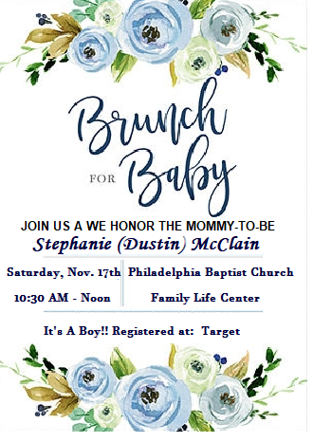
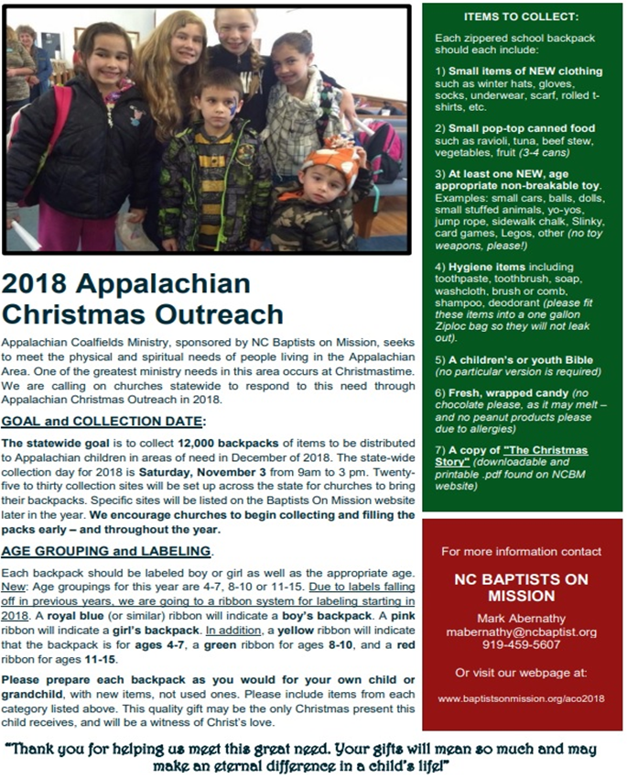
OUR CHURCH GOAL IS 50 BACKPACKS!

November 2018
Sunday Monday Tuesday Wednesday Thursday Friday Saturday
 |  |  |  | 1 | 2 | 3Appalachian Ministry Back Pack collection
4  Daylight Savings time ends | 5  NC Baptist Convention in Greensboro | 6 Election Day; NC Baptist Convention in Greensboro | 7 WMU, Wednesday night classes | 8 | 9 | 10
11 Church Conference; Veteran’s Day; AWANA-CAMO Night | 12 | 13 | 14  Adult Bible Study, Wednesday night classes | 15 | 16 | 17 Baby Shower for Dustin & Stephanie McClain 10:30 AM-Noon;  Thanksgiving Meal 6:00 PM  Family Life Center
18 Offering for NC Baptist Children’s Homes; Monroe Christmas Parade | 19 | 20 | 21  No Wednesday Night Services | 22  Thanksgiving Day | 23 | 24
25  AWANA Crazy Hair Night | 26 | 27  Deacon’s Meeting | 28  Adult Bible Study, Wednesday night classes | 29 | 30  Mission Trip to Rose Hill, VA
CHURCH SCHEDULE
Sunday: 10:00 AM Sunday School; 11:00 AM Morning Worship; 4:30-6:30 PM-AWANA; 6:30-AWANA Supper; 6:00 PM Youth, Adult Bible Study; 7:00 PM Evening Worship
Wednesday: 7:00 PM Mission Friends, GA, RA, Youth, GIC; WMU
on 1st Wednesday Night; Adult Bible Study on 2nd, 3rd, and 4th Wednesday Nights
Family Life Center Schedule: 1st Wed. of Month: Mission Friends; 2nd Wed. of Month: GA Class; 3rd Wed. of Month: RA Class; 4th Wed. of Month: Youth Class
Golden Age Group
SAVE THE DATE!!!
DATE: Wednesday, December 12th
TIME: 11:00 AM ● PLACE: Family Life Center
Please come out and join us for fun, fellowship, lunch and more.
Ralph Baker will be cooking our meal for us.

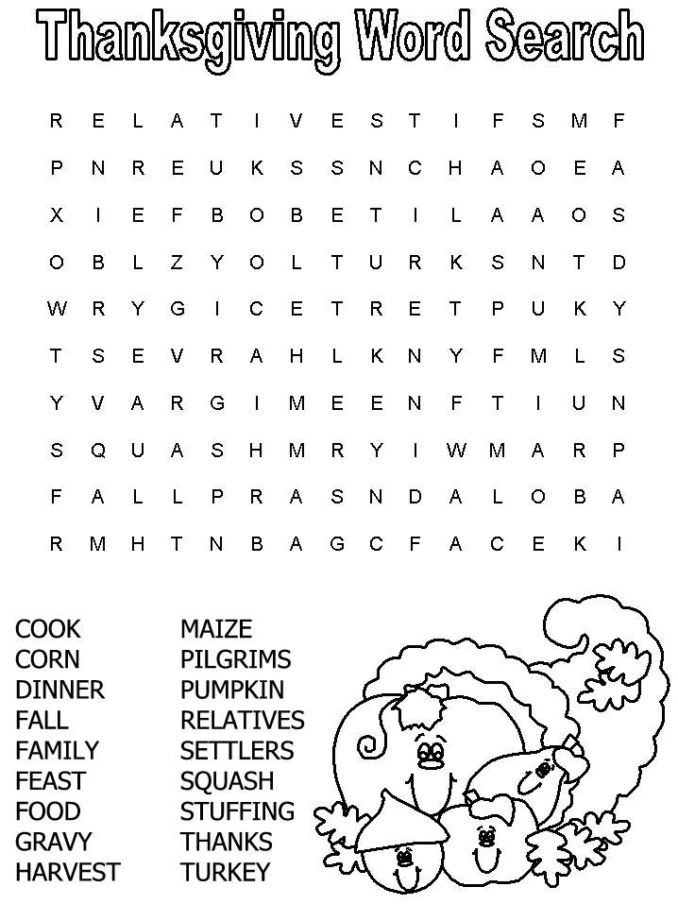
NOVEMBER AWANA MEAL VOLUNTEERS
4th: Whitney Beard & Luisa Price
11th: Kelly Baker & Peggy Smith
18th: Kristi & Roger Cox
25th: Amy Duke & Tonya Helms

Philadelphia Baptist Church
5709 Philadelphia Church Road
Marshville, NC 28103
pbcmarshville.org philadelphia1@windstream.net

BULK RATE NON-PROFIT
US POSTAGE PAID
PERMIT #28
MARSHVILLE, NC 28103

