**

________________________________________________

***We will continue to receive the NC Missions Offering throughout the month of September.***

________________________________________________

*Thank you so much for providing a meal for our family. Not only was it delicious, it was greatly appreciated. I know that Philadelphia was a special place for my mother and she loved it dearly. May God bless you all!! The Geneva Moore Family*

*Ben Moore & Family; Aileen Kirkley & Family*

*We deeply appreciate and gratefully acknowledge your kind expression of sympathy. May God Bless You All! It will always be remembered by the family of Geneva Moore.*

________________________________________________

Council on Aging: “A Matter of Balance” Class for Ages 60 & Over. Please contact Faye at Council on Aging at

704-292-1797 for more information.

________________________________________________

**Philadelphia Baptist Church**

5709 Philadelphia Church Road, Marshville, NC 28103

**704-624-5121**

[www.pbcmarshville.org](http://www.pbcmarshville.org); [philadelphia1@windstream.net](mailto:philadelphia1@windstream.net)

**Office Hours**

Monday, Tuesday, Wednesday

8:30 AM – 3:00 PM

*We have been given the opportunity to help with the FCA at Forest Hills High School. The FCA passes out Gatorade to the FHHS athletes as an opportunity to invite them to their Huddle (Bible Study). They are also in need of small individual bags of chips for their “Fields of Faith” event in October. If you would be willing to help with either of these, please drop off your donations on Sunday, September 30th. Thank you.*

_______________________________________________

***Creation Ministries International--*Get Answers!**

Does God exist? How can anyone believe in religion when science has neither a need nor a place for God? Is evolution happening today? If God is a God of love, why do we suffer

and die?

*Creation Ministries International* is coming to your area

soon with answers to these important questions. Come and hear Joel Tay expose the bankruptcy of the evolutionary myth.

You'll be amazed to see how weak the scientific evidence for evolution is. This is an issue that affects *everyone*. Evolution teaches us there is no need for God, there is no spiritual realm, and there is no afterlife. According to the theory, spirituality is just an evolutionary trick of the mind!

The Bible gives a very different picture about the nature of these things. At this presentation, you will learn how the scientific evidence, when properly understood, confirms the details of the biblical account. At the same time, we will answer many of the Big Questions.

To find out more:

**Date: Sunday, September 30, 2018**

**Time: 10:00 AM - Dinosaurs: Amazing Evidence for Creation!**

**11:00 AM - Creation: Impacting Our Culture**

________________________________________________

**AWANA CLUBS MEAL**

**TODAY: Karen Lowery & Morgan**

**NEXT WEEK: Carla Bowers & Crystal Craig**

**1st Dinner needs to be ready by 5:15 PM and can be dropped off at 5:00 PM. Please let Christa Rushing know if you are dropping off. Thank you.**

**Philadelphia Baptist Church**

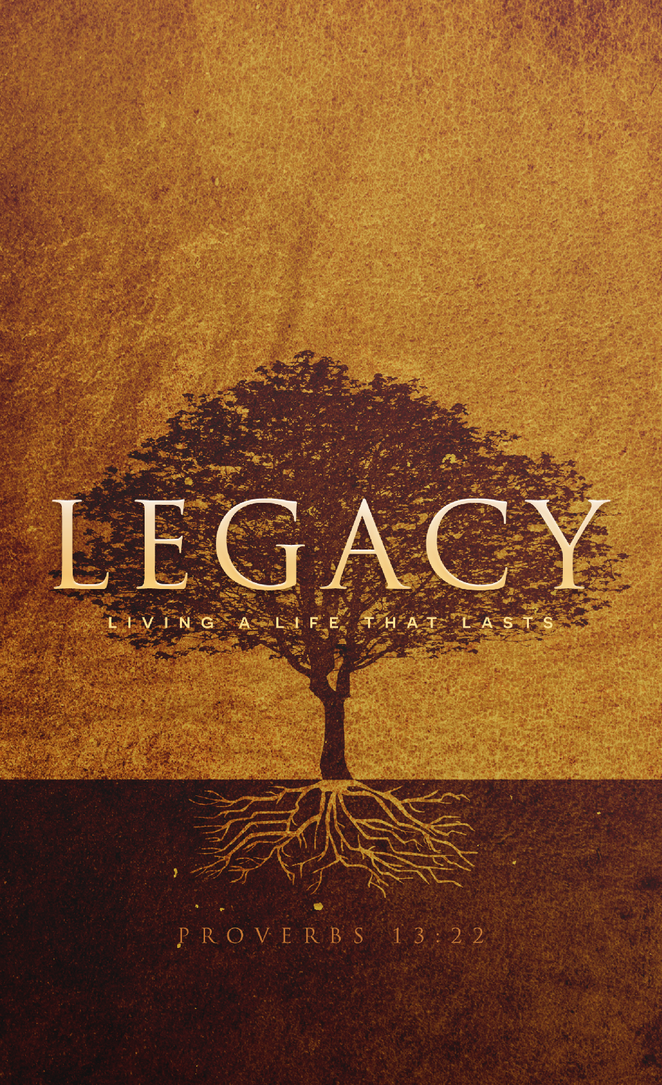

“The Legacy of Godly Parents”

Luke 1:5-25

**Our Lord's Day September 16, 2018**

**Morning Worship**

Prelude Organist

Call to Worship #177 “There’s Something About That Name” Congregation

Opening Prayer Pastor

Welcome & Announcements Pastor

Fellowship Chorus #386 “The Family of God” Congregation

Fellowship Time

Hymn #2 “Holy, Holy, Holy” Congregation

Tithes and Offerings Ushers

Children’s Sermon

Hymn #595 “Send the Light” Congregation

Choir

Scripture Luke 1:5-25 Pastor

Sermon Title “The Legacy of Godly Parents” Pastor

Invitation Hymn #320 “Turn Your Eyes upon Jesus” Congregation

Benediction _ Pastor



BECAUSE HUNGER DOESN’T TAKE THE WEEKEND OFF

**Items Needed:** individual cereal, grits and Pop Tarts. Please leave donations in the box in the vestibule.

**Thank you.**

____________________________________________________

**Evening Worship**

Prelude Organist

Call to Worship #177 “There’s Something About That Name” Congregation

Opening Prayer Pastor

Welcome and Announcements Pastor

Hymn #254 “Holy, Holy” Congregation

Scripture James 1:5-12 Pastor

Sermon "Conquering Temptation” Pastor

Benediction Pastor

_______________________________________________________

**Deacon of the Week:** Bill McLaurin; N**ext Week:** Roger Cox

**Opportunities of the Week**

**Sunday**

9:30 AM Prayer Time

10:00 AM Sunday School

11:00 AM Morning Worship

Autry Family Reunion in Family Life Center

4:30 PM AWANA Clubs

5:00-6:30 PM Youth

7:00 PM Evening Service, Youth

**Wednesday**

7:00 PM Mission Friends, GA, RA-FLC, Youth,

Adult Bible Study, Girlfriends in Christ

**Saturday** David Seymour Day at Camp Duncan

**Next Sunday** Special Guests: Shannon Powell & Donnie Gamble; Baby Shower for Haley (Jeremy) Nash from 2-4 PM in FLC-It’s A Girl! AWANA-Bring A Friend Day

____________________________________________________

Pastor Caroll and Sherrie will be leaving on Thursday for a

40th Anniversary cruise. They will return on Tuesday, September 25th. Please pray for them as they travel.

____________________________________________________

**Welcome Visitors**

Your presence today is a blessing. Thank you for choosing to worship with us. Please fill out a visitor card and place it in the offering plate or hand it to the Pastor. We pray your visit today meets your spiritual needs and you will choose to come again. God Bless You.

______________________________________________________

**FAMILY LIFE CENTER RESERVATIONS**

In an effort to better serve us all, when you or your group wants to use the Family Life Center for an event, please fill out a FLC request form (forms located in vestibule and outside secretary’s office) and turn it in to the **secretary’s mailbox located beside office door** or **secretary’s mailbox located in the Sunday School Office**. Approved events will be scheduled on a first come, first serve basis. All events must be approved by the deacons. We are blessed to have such a wonderful facility that many groups want to use, so we want to be fair with all. Thank you for your understanding in this.

**Stewardship/Enrollment Report: September 9, 2018**

Weekly Required: $ 7,689.56

Weekly Received: $ 10,148.21

Requirement to Date: $ 15,379.12

Received to Date: $ 16,775.36

S. S. Enrollment: 236; Present: 181

Discipleship Training Enrollment: 123; Present:  84

________________________________________________

**Prayer List**

**New:** Donald Tyner (Kim Outen’s Father’s Cousin)

**On-Going:** David Deese (Cindy Mangum’s Father),

Shelby Hendrickson (Marie Autry/Jackie Elison’s Cousin), Charles Knight, Nicky Lee, Chase Rushing, Bill Johnson, Laura Sims (Rachel Sims Brooks Daughter-in-law), Annette Haigler, Sherry Lane, John McManus, Richard Sexton, Jamie Jenkins, Lavonne Floyd, Ona Ruth Smith, Chris Courtney, Chris Jenkins, Paul Floyd, Ercel Timmons, Alisha Bell, Don Thompson, Virginia Rollins, Loree Evans, Annie Griffin, Elaine Price, Eva Spaide, Rachel Hamilton, Reagan Thomas, Willie Watts **Please contact our church office to update the Prayer list. Thank you.**

**____________________________________________________**

**Nursery Workers**

**Today:** Chad Clay & Whitney Beard

NextWeek: Kelly Baker & Brooke Baker

**Children’s Church Workers**

**2 & 3 year old’s class**

**Today:** Tony & Kara Keith

**Next Week:** Lauren Duke & Helper

**4 & 5-year old’s class**

**Today:**  Deneice Hendrick & Erin Felt

**Next Week:** Tonya & Kerstyn Helms

____________________________________________________

**R. Caroll Anthony, Pastor**

**Jeff Jenkins, Youth Minister Richard Taylor, Music Minister**

**Linda Day, Pianist Melba Zimmerman, Organist**

**Judy Rogers, Treasurer Sheri Autry-Rodgers, Secretary**