**

________________________________________________

*Thank you so much for providing a meal for our family. Not only was it delicious, it was greatly appreciated. I know that Philadelphia was a special place for my mother and she loved it dearly. May God bless you all!! The Geneva Moore Family*

*Ben Moore & Family; Aileen Kirkley & Family*

*We deeply appreciate and gratefully acknowledge your kind expression of sympathy. May God Bless You All! It will always be remembered by the family of Geneva Moore.*

________________________________________________

Council on Aging: “A Matter of Balance” Class for Ages 60 & Over. Please contact Faye at Council on Aging at

704-292-1797 for more information.

________________________________________________

*We have been given the opportunity to help with the FCA at Forest Hills High School. The FCA passes out Gatorade to the FHHS athletes as an opportunity to invite them to their Huddle (Bible Study). They are also in need of small individual bags of chips for their “Fields of Faith” event in October. If you would be willing to help with either of these, please drop off your donations on Sunday, September 30th. Thank you.*

_______________________________________________

**AWANA CLUBS MEAL**

**TODAY: Carla Bowers & Crystal Craig**

**NEXT WEEK: Lauren Davis & Mindy Jenkins1st Dinner needs to be ready by 5:15 PM and can be dropped off at 5:00 PM. Please let Christa Rushing know if you are dropping off. Thank you.**

***Creation Ministries International--*Get Answers!**

Does God exist? How can anyone believe in religion when science has neither a need nor a place for God? Is evolution happening today? If God is a God of love, why do we suffer

and die?

*Creation Ministries International* is coming to your area

soon with answers to these important questions. Come and hear Joel Tay expose the bankruptcy of the evolutionary myth.

You'll be amazed to see how weak the scientific evidence for evolution is. This is an issue that affects *everyone*. Evolution teaches us there is no need for God, there is no spiritual realm, and there is no afterlife. According to the theory, spirituality is just an evolutionary trick of the mind!

The Bible gives a very different picture about the nature of these things. At this presentation, you will learn how the scientific evidence, when properly understood, confirms the details of the biblical account. At the same time, we will answer many of the Big Questions.

To find out more:

**Date: Sunday, September 30, 2018**

**Time: 10:00 AM - Dinosaurs: Amazing Evidence for Creation!**

**11:00 AM - Creation: Impacting Our Culture**

_______________________________________________

**Philadelphia Baptist Church**

5709 Philadelphia Church Road, Marshville, NC 28103

**704-624-5121**

[www.pbcmarshville.org](http://www.pbcmarshville.org); [philadelphia1@windstream.net](mailto:philadelphia1@windstream.net)

**Office Hours**

Monday, Tuesday, Wednesday

8:30 AM – 3:00 PM

________________________________________________

**R. Caroll Anthony, Pastor**

**Jeff Jenkins, Youth Minister Richard Taylor, Music Minister**

**Linda Day, Pianist Melba Zimmerman, Organist**

**Judy Rogers, Treasurer Sheri Autry-Rodgers, Secretary**

**Philadelphia Baptist Church**

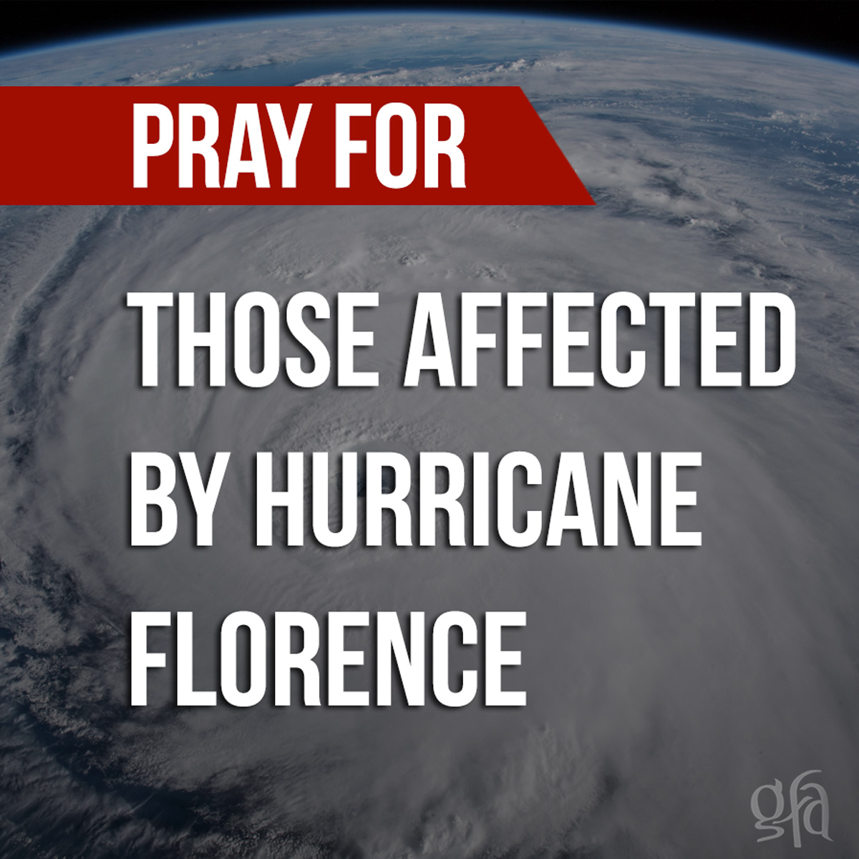

***As you know, Hurricane Florence devasted much of Eastern North Carolina. North Carolina Baptist Men were on site the day after the storm passed, preparing meals and helping with the recovery efforts. Recovery and rebuilding efforts will require volunteer teams for months to come. Once we are aware of specific needs, we will pass those along. Of course, you can always visit their website at*** [www.baptistsonmission.org](http://www.baptistsonmission.org) ***for the latest updates.***

***We will continue to receive the***

***NC Missions Offering***

***throughout the month of September.***

**Our Lord's Day September 23, 2018**

**Morning Worship**

Prelude Organist

Call to Worship #177 “There’s Something About That Name” Congregation

Opening Prayer

Welcome & Announcements

Fellowship Chorus #386 “The Family of God” Congregation

Fellowship Time

Hymn #2 “Holy, Holy, Holy” Congregation

Tithes and Offerings Ushers

Children’s Sermon

Hymn #595 “Send the Light” Congregation

Choir

Sermon Rev. Shannon Powell

Invitation Hymn #320 “Turn Your Eyes upon Jesus” Congregation

Benediction _ _____



**BECAUSE HUNGER DOESN’T TAKE THE WEEKEND OFF**

**Items Needed:** individual cereal, grits and Pop Tarts. Please leave donations in the box in the vestibule.

**Thank you.**

____________________________________________________

**Evening Worship**

Prelude Organist

Call to Worship #177 “There’s Something About That Name” Congregation

Opening Prayer

Welcome and Announcements

Hymn #254 “Holy, Holy” Congregation

Scripture James 1:5-12

Sermon Rev. Donnie Gamble

Benediction

_______________________________________________________

**Deacon of the Week:** Roger Cox; N**ext Week:** Tony Keith

**Opportunities of the Week**

**Sunday**

9:30 AM Prayer Time

10:00 AM Sunday School

11:00 AM Morning Worship

Special Guest: Rev. Shannon Powell

2:00-4:00 PM Baby Shower: Haley (Jeremy) Nash in FLC-It’s A Girl!

4:30 PM AWANA Clubs: “Bring A Friend” Day

5:00-6:30 PM Youth

7:00 PM Evening Service, Special Guest: Rev. Donnie Gamble, Youth

**Wednesday**

**See You At The Pole**

Students, please check with your school for time.

7:00 PM Mission Friends, GA, RA, Youth-FLC,

Adult Bible Study, Girlfriends in Christ

**Thursday**

7:00 PM Deacon’s Meeting (Rescheduled from Tuesday)

**Next Sunday**

10:00 & 11:00 AM Creation Ministries presentation in the FLC; Final day to receive the NC Missions Offering. FCA donations (Gatorade & individual bags of chips) due.

____________________________________________________

Pastor Caroll and Sherrie are away until Tuesday. They are taking a 40th Anniversary Cruise. Please pray for them as they travel.

____________________________________________________

**Welcome Visitors**

Your presence today is a blessing. Thank you for choosing to worship with us. Please fill out a visitor card and place it in the offering plate or hand it to the Pastor. We pray your visit today meets your spiritual needs and you will choose to come again. God Bless You.

______________________________________________________

The following gave gifts to the Building Fund

***In Memory of Geneva Moore***:

Butch & Melba Zimmerman, Judy Rogers,

Richard & Joyce Kirkley, Robert & Bonnie Oster,

Mildred C. Hunsucker, City of Monroe, Peggy McKenzie

**Stewardship/Enrollment Report: September 9, 2018**

Weekly Required: $ 7,689.56; Weekly Received: $ 10,148.21

Requirement to Date: $ 15,379.12

Received to Date: $ 16,775.36

S. S. Enrollment: 236; Present: 181

Discipleship Training Enrollment: 123; Present:  84

Due to Hurricane Florence church was cancelled last Sunday.

________________________________________________

**Prayer List**

**New:** Donald Tyner (Kim Outen’s Father’s Cousin),

**On-Going:** David Deese (Cindy Mangum’s Father),

Shelby Hendrickson (Marie Autry/Jackie Elison’s Cousin), Charles Knight, Nicky Lee, Chase Rushing, Bill Johnson, Laura Sims (Rachel Sims Brooks Daughter-in-law), Annette Haigler, Sherry Lane, John McManus, Richard Sexton, Jamie Jenkins, Lavonne Floyd, Ona Ruth Smith, Chris Courtney, Chris Jenkins, Paul Floyd, Ercel Timmons, Alisha Bell, Don Thompson, Virginia Rollins, Loree Evans, Annie Griffin, Elaine Price, Eva Spaide, Rachel Hamilton, Reagan Thomas, Willie Watts **Please contact our church office to update the Prayer list. Thank you.**

**____________________________________________________**

**Nursery Workers**

**Today:** Kelly & Brooke B.; NextWeek: Michelle & Emma S.

**Children’s Church Workers**

**2 & 3 year old’s class**

**Today:** Lauren Duke & Helper; **Next Week:** Mary K. & Michael

**4 & 5-year old’s class**

**Today:**  Tonya & Kerstyn Helms; **Next Week:** Kathy & Jill

____________________________________________________

**FAMILY LIFE CENTER RESERVATIONS**

In an effort to better serve us all, when you or your group wants to use the Family Life Center for an event, please fill out a FLC request form (forms located in vestibule and outside secretary’s office) and turn it in to the **secretary’s mailbox located beside office door** or **secretary’s mailbox located in the Sunday School Office**. Approved events will be scheduled on a first come, first serve basis. All events must be approved by the deacons. We are blessed to have such a wonderful facility that many groups want to use, so we want to be fair with all. Thank you for your understanding in this.