Philadelphia Baptist Church
5709 Philadelphia Church Road, Marshville, NC 28103; 704-624-5121
Website: pbcmarshville.org E-mail: philadelphia1@windstream.net
____________________________________________________________________________
Dear Family of God of Philadelphia,
First of all, Sherrie and I want to express our deepest gratitude to you for your gift to us on our 18th anniversary of serving at PBC. You have always been loving and generous toward us, and I truly know of no place I would rather serve. Thank you.
As I write this, we are preparing for our annual men’s retreat at Fort Caswell. And our PBC men are on my mind. I saw a recent survey taken among “practicing Christians.” In other words, among those who read the Word, pray and attend church on a regular basis. The survey essentially asked them, “Whose faith influenced you in your faith, your mother or your father?” Here are some of the results:
Whose faith influenced you? Mother 68% Father 46%
Who prayed with you? Mother 63% Father 53%
Who discussed the Bible with you? Mother 71% Father 50%
Who taught you about God’s forgiveness? Mother 66% Father 47%
Who encouraged you to go to church? Mother 79% Father 64%
Who taught faith by setting an example? Mother 73% Father 71%
We just celebrated Mother’s Day, and I can tell you that my own mother had and continues to have a tremendous impact on my faith. Thank God for godly mothers. But, the responsibility of being the spiritual leader in the home has been given to men.
Since God is described as our Heavenly Father, in a sense, men are to be the example of what God is like. Since God is loving, no one should be more loving than a father. Since God is merciful, fathers are to demonstrate that mercy to their children. And since God, in the form of Jesus came to be a servant and a sacrifice, no one should serve the family or sacrifice more for the family than the father. According to this survey, us men must do better. We must use the tremendous influence we have to lead our children to Christ.
May our Father bless you today. It is a joy to serve our Lord with you.
RCA

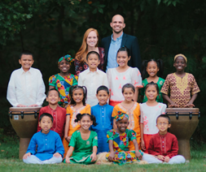

Children of the World choir will be in concert Wednesday, June 5th at 7:00 PM. This week is their last week of concerts before they go back to their native homes. Please come join us!
Philadelphia Baptist Church
5709 Philadelphia Church Road
Marshville, NC 28103

Remember: “Only one life will soon be past. Only what is done for Christ will last.”

BULK RATE NON-PROFIT
US POSTAGE PAID
PERMIT #28
MARSHVILLE, NC 28103

Sunday Monday Tuesday Wednesday Thursday Friday Saturday
 |  |  |  |  |  | 1 Men’s Retreat at Caswell
2 Sunday Services  VBS Volunteer meeting following morning worship. | 3  Ladies Bible Study in Conf. Room  7:00 PM | 4 | 5  “Children of the World” Concert 7:00 PM | 6 | 7 | 8
9 Sunday Services/Church Conference  Bridal Shower for Malorie Ruple &  Will Autry 2-4 PM;  Deadline to turn in Baby Dedication forms (forms located on our website to submit.) | 10  10th-12th Southern Baptist Convention | 11 | 12  WMU meets tonight;  Wednesday Night Services | 13 | 14 | 15
16 Happy Father’s Day!  Sunday Services Father’s Day-No Evening Services  AM: Baby Dedication | 17  Pastor Caroll & Sherrie on vacation  17th – 22nd | 18  Ladies Breakfast at Beth’s Restaurant  8:30 AM | 19  Wednesday Night Services | 20 | 21 | 22
23  Sunday Services  PM: VBS  6-9 PM  30  Sunday Services  AM: Communion | 24  VBS  6-9 PM | 25  VBS  6-9 PM | 26  VBS  6-9 PM | 27  VBS  6-9 PM | 28  VBS Commencement  6:00 PM | 29

CHURCH SCHEDULE
Sunday: 10:00 AM Sunday School; 11:00 AM Morning Worship; 4th & 5th Sundays: 4:00 PM Children’s Choir Practice; 4:30-6:30 PM-AWANA; 6:30-AWANA Supper; 6:00 PM Youth, Adult Bible Study; 7:00 PM Evening Worship.
Wednesday: 7:00 PM Mission Friends, GA, RA, Youth, GIC; WMU on 1st Wednesday Night; Adult Bible Study on 2nd, 3rd, and 4th Wednesday Nights
Family Life Center Schedule: 1st Wed. of Month: Mission Friends; 2nd Wed. of Month:
GA Class; 3rd Wed. of Month: RA Class; 4th Wed. of Month: Youth Class
June
1-Leigha Stegall Rollins, Brystal Wallace

2-Jeff “Jenks” Jenkins, Devin Layser
6-Jerry Rollins
9-Yates Pope
11-Joyce Kirkley
12-John Baker
13-Chad McClain
14-Jamie Forester
15-Luke Hinson, Alexis Jenkins, Madeline Wilson
17-Becca Altman, J. Ashcraft, III, Brooke Baker
19-Camila Cox, Juanita McClain
20-Cindy Mangum
21-Roger Cox
22-Johnny Jenkins
23-Tommy Parker
24-Lynn Moore
25-Barry Hilton
26-AJ Starnes
27-Jase Davis, Sean McClain
28-Sherry Lane, Cooper McClain, Sheri Rodgers

First Week of July
1-Jared Lowery, Kelly Rorie, Dex Stanley
2-Tricia Lilly
6-Cathy Bradford
7-Brayden Helms, Aly Mills, Tyler Pittman, Candace Pope, Jana Turner

NURSERY WORKERS
June
2nd - Kaylee Duke and Lacy Lee
9th - Lauren Jenkins Davis and Mindy Jenkins
16th - No Nursery
23rd - Jen Myers and Kate Rapp
30th - Sherry Nash and Vanna Nash
July
7th - Kaylee Duke and Lacy Lee

CHILDREN’S CHURCH WORKERS: For ages 2 to 5 years old.
2/3 Year Old’s 4/5 Year Old’s
June 2nd - Carla Bowers & Kaylee Duke Lauren Davis & Mindy Jenkins
9th - Sherry Nash & Vanna Nash Kim Outen & Ashlynn Porter
16th - Jen Myers & Kate Rapp Sheri Rodgers, Ava Strawn
23rd - Tony & Kara Keith Deneice Hendrick & Erin Felt
30th - Peggy Smith & Kelly Baker Deborah Sullivan & Jennifer Helms
July 7th - Crystal Craig & Chad Clay Tonya & Kerstyn Helms

Wednesday Night Mission Friend Workers
June
5th – Carl Bowers & Lisa Stutts
12th – Sheri Rodgers, Ava Strawn, Karlie Strawn
19th – Skyla Anderson, Kasey Wallace
26th – Amanda & Jeff Tarlton
July
3rd – Peggy Smith, Kelly Baker
__________________________________________________________________

If you would like to have a rightnow MEDIA library account, you can set your account up at the following link or please contact Sheri on Monday through Wednesday in the church office at 704-624-5121. She will need your email address. Thank you.
Church App
Go to the App Store, then under Search, type in Sharefaith, it will look like:
Download the App and Open.
Under Find Your Church/Ministry, type in PBCMarshville and click on PBC Marshville, then click “Save”, then click “Default”, then choose to receive notifications or not.
With the App you can access: Sermons, Connect with us through Facebook, (Twitter coming soon), E-mail and Phone, Location/Map, Donate/Give, Bible App, Weekly Bulletin, Monthly Newsletter and a Calendar! ENJOY!
_____________________________________________________________________________
Youth
Summer
Camp at Caswell
July 15-20, 2019
Cost $150
See Jenks for details.
Children’s Choir Members
Enjoy Summer!
We will start back our choir practices in August!

Baby Dedication Day
Sunday, June 16th at 11:00 AM
If you would like to participate, please go to www.pbcmarshville.org and click on Forms, then Baby Dedication Form fill out and send. Deadline to send in forms is Sunday, June 9th.

VACATION BIBLE SCHOOL
Sunday, June 23rd – June 28th
6:00 PM – 9:00 PM

If you can come and help out any night, please do. We can always use extra volunteers in the kitchen, as teacher assistants, in crafts, etc. Please go online and fill out the Safe Sanctuary Form before VBS starts. Thank you.

Parents, please go online to register your child in VBS (click on forms, then click on Vacation Bible School) or register your child on their first night in attendance in the vestibule of the church.
VBS Volunteers
Nursery – 1’s - Tonya Helms & Amy Duke
2's & 3's - Jeff and Amanda Tarlton, Tricia Lily
4's - Kasey Wallace & Kate Rapp
Kindergarten - Kim & Greg Outen, Vanna Nash
1st - Avery Selby & Sherry Nash
2nd - Michelle Query, Need Volunteer
3rd - Kathy Brock & Jill Aldridge
4th - Linda Day & Jana Turner
5th & 6th - Doug & Skyla Anderson, Peggy Smith
Youth - Jeff & Mindy Jenkins, Chris Davis
Preschool Music - Jen Myers
Preschool Missions - Carla Bowers & Ava Strawn
School Aged Music - Crystal Rowell & Melba Zimmerman
School Aged Missions - Mary Katherine Atkinson
Crafts - Christa Rushing, Chad Clay, Kara Keith, Need Volunteers
Kitchen - Need Volunteers - See Lauren Davis or Michelle Simpson to sign up.
Volunteer: Sheri Rodgers
Security - Need Volunteers - See Lauren Davis to Sign Up
Recreation - Need Volunteers - See Lauren Davis to Sign Up
We will be having a short meeting after morning worship on June 2nd as a touch base and to obtain shirt sizes of anyone interested in ordering a shirt.
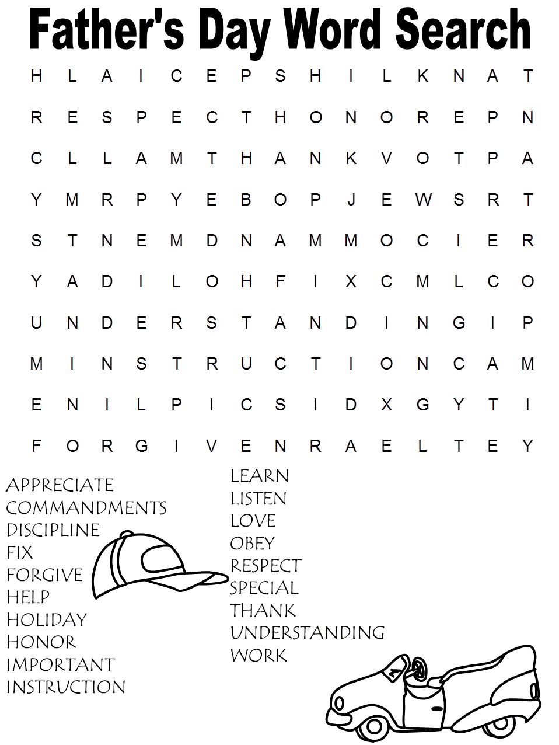
You are invited to a Bridal Shower
For: Malorie Ruple (Will Autry)
Date: Sunday, June 9th
Time: 2:00-4:00 PM
Place: Family Life Center

The Future Autry’s are asking for gift cards to Disney, Lowe’s, and Walmart!!

