Philadelphia Baptist Church
5709 Philadelphia Church Road, Marshville, NC 28103
704-624-5121
Website: pbcmarshville.org
E-mail: philadelphia1@windstream.net

2018
____________________________________________________________________________
Dear Family of God of Philadelphia,
As I am writing this, it is the first day after Sherrie and I returned from our cruise. As per usual, today will be spent unpacking, paying bills, and trying to get through the 275 e-mails that my phone continually reminds me about.
This was our second cruise. The first one we took more than 30 years ago when Scottish Food Systems picked up the tab. This one, I won in a drawing at a pastor’s conference I attended back in January.
Cruising has changed quite a bit in 30 years. The ships are much bigger. (Our ship this week had 14 decks.) The staterooms are much nicer. And now, you don’t even have to take turns rowing as we did on the prior cruise. (Just kidding).
One thing that has not changed is the service onboard the ship. Our ship had almost 4,000 passengers from all over the world. There was a wide diversity of needs and wants. The age of the passengers ranged from small children to senior adults. Some of them were very demanding, while others were content to just be on the ship. Some of them were there to drink and party, while others were there to rest. Most spoke at least some English, but there were some who spoke no English at all. Trying to meet the multiplicity of needs were those who were onboard to serve.
I learned some things about being a true servant by watching them.
** True servants enjoy serving. From the person who made up our bed each day, to the ship’s crew, to the entertainers, to those who served us our meals, all were smiling and eager to do a great job.
** True servants get to know those they are serving. Our waiter called us by name. Our cabin attendant learned our habits, so he could serve us without being intrusive.
** True servants have no other agenda but to serve. While we enjoyed the wonderful food, the amazing entertainment and relaxed by the pool, they just continued to serve.
We, who are servants of the Most High, could learn a lot from them. Matthew 20:26 says this: “…but whoever desires to be great among you, let him be your servant.” Greatness in God’s Kingdom is defined by servanthood.
May our Father bless you today. It is a joy to serve our Lord with you.
RCA
WEDNESDAY, OCTOBER 31st 6:00 – 8:00 PM
We will also have a Hot-Dog Supper & Cake Walk
We need YOU to set up YOUR cars and/or trucks for Trunk or Treat for the children and cake/goodie donations for the children and adults😊 If you can set up a game/booth and/or candy give-away, please contact the church office or sign up on the bulletin board across from the Sunday School Office to let us know. Also, if you have a four-wheeler and wagon and can run hayrides for us, please call and let us know that also.
__________________________________________________________________
On Sunday, October 14th we will be receiving an offering for the NC/SC Baptist Men Disaster Relief Fund for those affected by Hurricane Florence.
__________________________________________________________________

FAMILY LIFE CENTER RESERVATIONS
In an effort top better serve us all, when you or your group wants to use the Family Life Center for an event, please fill out a FLC request form (forms located in vestibule and outside secretary’s office) and turn it in to the secretary’s mailbox located beside office door or secretary’s mailbox located in the Sunday School Office. Approved events will be scheduled on a first come, first serve basis. All events must be approved by the deacons. We are blessed to have such a wonderful facility that many groups want to use, so we want to be fair with all. Thank you for your understanding in this.
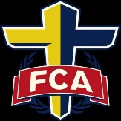
If you are interested in helping PBC provide a meal for the Wingate Fellowship of Christian Athletes, please contact Pastor Caroll at 980-328-5610. Thank you.
__________________________________________________________________
1- Edward Haigler
2- Chuck Newland
4-Kim Ashcraft, Morgan Lowery Farthing, Kyle Strawn
7-Alexis Chambers, Charlie Craig, Annette Forester, Andrea Helms
9- Brandon Mills, Coulson Rushing
10-CJ Rushing
11-Mary Autrey, Christopher Glidewell
12-Rick Pressley, Katelynn Rapp
13-Lydia Medlin
14-Chelsea Autry
15-Bruce Aldridge, Sherrie Anthony, Deann Jenkins, Jenna Jenkins, Pamela Lowery
17-Brad Baker, Evan Keith
18-Buddy Hancock
19-Chris Jenkins, Cole Lowery
20-Meredith Grimes, Ginger Nance
21-Ritchie Simpson
22-Brian Helms, Kelly Ratliff
23-Mary Hancock
24-Ryan Mabe
25-Kerstyn Helms, Mitchell Lowery, Joshua Lowery
27-John Ashcraft. Jr., Debra Pressley
28-Matthew Hinson
29-Rita Jenkins, Joshua Stegall
30-Karen Lowery, Virginia Rollins, Rodney Strawn, Scott Stutts
31-Carol Courtney

___________________________________________________________
NURSERY WORKERS
October 7th - Tonya Helms and Amy Duke
October 14th - Erin Felt and Deneice Hendrick
October 21st - Kaylee Duke and Lacy Lee
October 28th - Crystal Craig and Carla Bowers
___________________________________________________________
CHILDREN’S CHURCH WORKERS
Children’s Church is for ages 2 to 5 years old.
2 & 3 Year Old’s 4 & 5 Year Old’s
October 7th: Carla Bowers & Kaylee Duke Lauren Davis & Mindy Jenkins
October 14th: Jennifer & Bob Selby Kim Outen & Ashlyn Porter
October 21st: Sherry & Vanna Nash Sheri Rodgers & Ava Strawn
October 28th: Jen Myers & Kate Rapp Peggy Smith & Kelly Baker

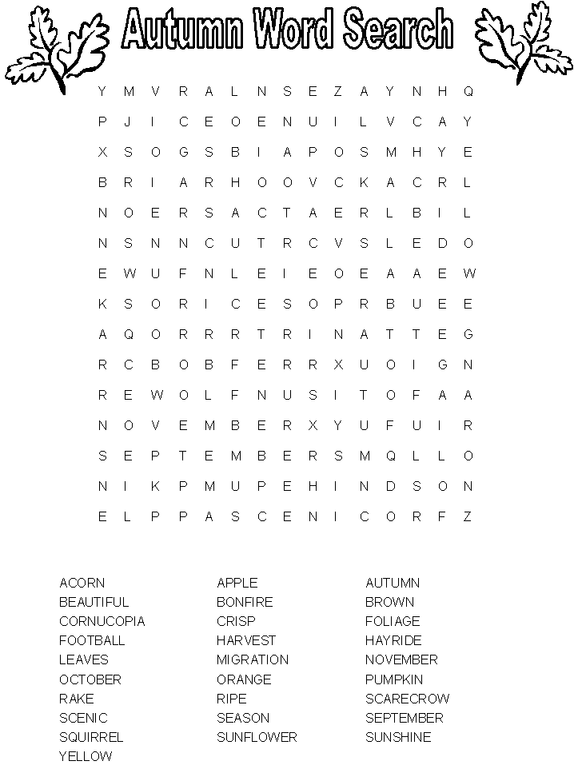

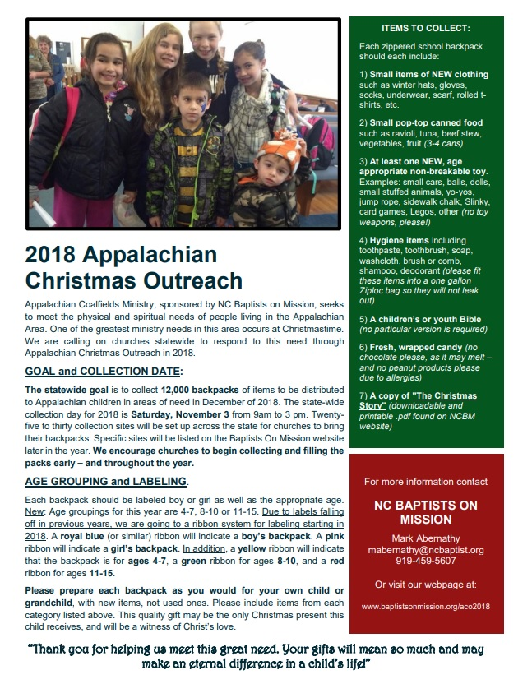
OUR CHURCH GOAL IS 50 BACKPACKS!

October 2018

OCTOBER 2018
Sunday Monday Tuesday Wednesday Thursday Friday Saturday
 | 1  Feed Wingate FCA | 2 | 3  WMU meets; Mission Friends-FLC | 4 | 5  Men’s Retreat at Blowing Rock Conf. Center  5th-7th | 6
7 | 8 | 9 | 10  GA’s-FLC | 11 | 12 | 13
14 NC/SC Baptist Men Disaster Relief Fund Offering;  Church Conference  AWANA: Western Night | 15 | 16  FLU Shot Clinic at UBA  11 AM- 3 PM | 17  RA’s-FLC | 18 | 19 | 20
21 | 22 | 23  UBA Annual Session at Benton’s Crossroads | 24  YOUTH-FLC | 25 | 26  FLU Shot Clinic at UBA  11 AM- 2 PM | 27 Baby Shower for Hailey Turner  2-4 PM in FLC; It’s a Girl!
28  AWANA: Dress Up Night | 29 | 30  Deacon’s Meeting | 31  Trunk or Treat & Hot Dog Supper  6-8 PM | NOV 1 | NOV 2 | NOV 3  Appalachian Christmas  Backpacks Due Date
CHURCH SCHEDULE
Sunday: 10:00 AM Sunday School; 11:00 AM Morning Worship; 4:30-6:30 PM-AWANA; 6:30-AWANA Supper; 6:00 PM Youth, Adult Bible Study; 7:00 PM Evening Worship
Wednesday: 7:00 PM Mission Friends, GA, RA, Youth, GIC; WMU on 1st Wednesday Night; Adult Bible Study on 2nd, 3rd, and 4th Wednesday Nights

OCTOBER AWANA MEAL VOLUNTEERS
7th: Skyla & Doug Anderson
14th: Amona Sunday School Class
21st: Nancy Glidewell & Kara Keith
28th: Frances Baker

PBC Church Family & Friends,
If you would like to be added to our Phone Tree, please contact the church office at 704-624-5121 or
E-mail at us philadelphia1@windstream.net by October 10th to update your records and in the Subject Line please put PHONE TREE INFORMATION. Also, we are trying to update our Phone App and we need your E-mail address for that also, so please E-mail us and in the Subject Line put PHONE APP. We will be updating our records and you will be receiving information soon regarding the Phone App for our Online Church Directory. Thank you.

Philadelphia Baptist Church
5709 Philadelphia Church Road
Marshville, NC 28103
pbcmarshville.org philadelphia1@windstream.net

BULK RATE NON-PROFIT
US POSTAGE PAID
PERMIT #28
MARSHVILLE, NC 28103

